**Library Management System**

**Team Members**

* **Name: Hanin Fathy Ramsis    ID: 221001780**
* **Name: Hodda Emad Eldeen    ID: 221001807**
* **Name: Rana Shehta Gaber    ID: 221001275**
* **Name: Moatz Hazem Nassar    ID: 221000418**
* **Name: Shahd Rafat Gamil ID: 221001378**
* **Name: Judy Ahmed Mahmoud ID: 221001698**

**1. System Overview**

The Library Management System is designed to manage all aspects of library operations including member management, book inventory, borrowing/returning processes, staff management, and library events. The system supports multiple transaction types and maintains comprehensive records of all library activities.

**2. Entity Relationship Model**

**2.1 Core Entities**

**Members**

* **MemberID** (Primary Key)
* **MemberDetails** (Name, Address, Contact Information)
* **RegistrationDate**
* **LoanHistory**
* **Transactions_ID** (Foreign Key)

**Books**

* **Books_ID** (Primary Key)
* **Title**
* **Publish_date**
* **Description**
* **book_category**
* **Price**
* **ISBN**
* **AvailabilityStatus**

**Author**

* **Author_ID** (Primary Key)
* **Email**
* **phone_no**
* **Author_name**

**Publisher**

* **Publisher_ID** (Primary Key)
* **Pub_Name**
* **language**

**Staff**

* **Staff_ID** (Primary Key)
* **Email**
* **address**
* **phone_no**
* **Sta_Name**
* **hire_date**
* **Role**

**Transactions**

* **Transactions_ID** (Primary Key)
* **Transactions_Date**
* **Due_date**
* **Transaction_type**

**Book Request**

* **Request_ID** (Primary Key)
* **request_date**

**Fines**

* **FineID** (Primary Key)
* **OverDue_Days**
* **fine_total**
* **Paid_Status**
* **Transactions_ID** (Foreign Key)

**library_events**

* **event_id** (Primary Key)
* **event_name**
* **location**
* **date**
* **description**

**2.2 Relationship Tables**

**Author-Book (Many-to-Many**

**)**

* **Author_ID** (Foreign Key)
* **Books_ID** (Foreign Key)

**Publisher-Book (Many-to-Many)**

* **Books_ID** (Foreign Key)
* **Publisher_ID** (Foreign Key)

**event-member (Many-to-Many)**

* **MemberID** (Foreign Key)
* **event_id** (Foreign Key)

**event-staff (Many-to-Many)**

* **Staff_ID** (Foreign Key)
* **event_id** (Foreign Key)

**transaction-staff (Many-to-Many)**

* **Transaction_ID** (Foreign Key)
* **Staff_ID** (Foreign Key)

**transaction-Book (Many-to-Many)**

* **Transaction_ID** (Foreign Key)
* **Books_ID** (Foreign Key)

**transaction-Book_request (Many-to-Many)**

* **Transaction_ID** (Foreign Key)
* **Request_ID** (Foreign Key)

**2.3 Transaction Subtypes**

**Reserve**

* **Transactions_ID** (Primary Key/Foreign Key)
* **Pickup_Date**
* **Transactions_Date**
* **Due_date**
* **Transaction_type**

**Renew**

* **Transactions_ID** (Primary Key/Foreign Key)
* **Loan_Period**
* **Transactions_Date**
* **Due_date**
* **Transaction_type**

**Borrow**

* **Transactions_ID** (Primary Key/Foreign Key)
* **Fine_Amount**
* **Transactions_Date**
* **Due_date**
* **Transaction_type**

**Return**

* **Transactions_ID** (Primary Key/Foreign Key)
* **Renewal_Count**
* **Previous_Due_Date**
* **Transactions_Date**
* **Due_date**
* **Transaction_type**

**3. Business Rules**

**3.1 Member Management Rules**

1. **Member Registration**: Each member must provide valid identification and contact information
2. **Membership Status**: Members can be Active, Suspended, or Expired
3. **Contact Information**: Each member must have at least one phone number
4. **Maximum Loans**: A member can borrow maximum 5 books simultaneously
5. **Overdue Restrictions**: Members with overdue books cannot borrow new books until returned

**3.2 Book Management Rules**

1. **Unique ISBN**: Each book must have a unique ISBN
2. **Availability Status**: Books can be Available, Borrowed, Reserved, or Under Maintenance
3. **Author Assignment**: Each book must have at least one author
4. **Publisher Information**: Each book must be associated with a publisher
5. **Category Classification**: All books must be assigned to a category

**3.3 Transaction Rules**

1. **Loan Period**: Standard loan period is 14 days for most books
2. **Reference Books**: Reference books cannot be borrowed, only used in-library
3. **Renewal Limit**: Books can be renewed maximum 2 times if no reservations exist
4. **Reservation Priority**: Reserved books are held for 3 days after notification
5. **Late Returns**: Overdue books incur daily fines after grace period

**3.4 Fine Management Rules**

1. **Fine Calculation**: LE 2 per day for overdue regular books, LE 5 for reference materials
2. **Maximum Fine**: Fine cannot exceed 50% of book's replacement cost
3. **Payment Methods**: Fines can be paid in cash or deducted from deposit
4. **Fine Waiver**: Staff can waive fines up to LE 10 with manager approval

**3.5 Staff Management Rules**

1. **Role-Based Access**: Staff access is limited based on their role (Librarian, Assistant, Manager)
2. **Transaction Authority**: Only authorized staff can process certain transaction types
3. **Event Management**: Staff can organize and participate in library events
4. **Work Schedule**: Staff availability must be maintained for proper library operations

**4. User Privileges & Access Control**

**4.1 Manager Privileges**

* **Full System Access**: Complete read/write access to all system components
* **Staff Management**: Hire, fire, and modify staff roles and permissions
* **Financial Operations**: View all financial reports, waive fines up to any amount
* **System Configuration**: Modify system settings, business rules, and policies
* **Advanced Reporting**: Access to all analytical reports and member data
* **Event Authorization**: Approve and cancel library events
* **Data Management**: Backup, restore, and maintain system data integrity

**4.2 Librarian Privileges**

* **Member Management**: Register new members, update member information, suspend accounts
* **Transaction Processing**: Process all transaction types (borrow, return, reserve, renew)
* **Book Management**: Add new books, update book information, manage inventory
* **Fine Management**: Calculate fines, accept payments, waive fines up to LE 50
* **Event Management**: Create and manage library events
* **Basic Reporting**: Generate circulation reports, overdue lists, and member activity reports
* **Author/Publisher Management**: Add and update author and publisher information

**4.3 Library Assistant Privileges**

* **Basic Transactions**: Process borrowing and returning transactions only
* **Member Lookup**: View member information and transaction history
* **Book Search**: Search and view book availability and details
* **Fine Collection**: Accept fine payments, cannot waive fines
* **Event Support**: Assist with event registration and check-in
* **Limited Reporting**: Generate basic daily transaction reports
* **Inventory Support**: Update book status and location information

**4.4 Member Self-Service Privileges**

* **Personal Account**: View personal borrowing history and current loans
* **Book Search**: Search catalog and check book availability
* **Renewals**: Renew eligible books online
* **Reservations**: Place holds on available books
* **Fine Payment**: View outstanding fines and payment history
* **Event Registration**: Register for library events
* **Profile Update**: Update contact information and preferences

**4.5 Guest/Public Privileges**

* **Catalog Search**: Search book catalog and availability
* **Library Information**: View library hours, location, and general information
* **Event Calendar**: View upcoming library events
* **Membership Information**: Access membership registration requirements

**3.6 System Rules**

1. **Data Integrity**: All foreign key relationships must be maintained
2. **Audit Trail**: All transactions must be logged with staff ID and timestamp
3. **Backup Policy**: System data must be backed up daily
4. **User Sessions**: Staff sessions timeout after 30 minutes of inactivity

**4. System Scenarios**

**4.1 Book Borrowing Scenario**

**Scenario**: Member Ahmed wants to borrow "Database Systems" book

**Steps**:

1. **Member Verification**: Staff verifies Ahmed's membership status and checks for outstanding fines
2. **Book Availability Check**: System checks if "Database Systems" is available
3. **Loan Limit Check**: System verifies Ahmed hasn't exceeded maximum loan limit (5 books)
4. **Transaction Creation**: Staff creates a new Borrow transaction
5. **Due Date Calculation**: System sets due date to 14 days from transaction date
6. **Book Status Update**: Book status changes from "Available" to "Borrowed"
7. **Receipt Generation**: System generates loan receipt with return date

**Business Rules Applied**:

* Member must be in good standing
* Book must be available for borrowing
* Loan period is 14 days
* Maximum 5 books per member

**4.2 Book Return Scenario**

**Scenario**: Member Sara returns "Python Programming" book (3 days overdue)

**Steps**:

1. **Book Identification**: Staff scans book barcode or enters ISBN
2. **Return Processing**: System identifies the borrowing transaction
3. **Overdue Check**: System calculates overdue days (3 days)
4. **Fine Calculation**: System calculates fine (3 days × LE 2 = LE 6)
5. **Fine Recording**: New fine record created and linked to member
6. **Book Status Update**: Book status changes to "Available"
7. **Reservation Check**: System checks if book is reserved by another member
8. **Transaction Completion**: Return transaction is recorded

**Business Rules Applied**:

* Overdue fine is LE 2 per day
* Fine must be paid before borrowing new books
* Returned books become available unless reserved

**4.3 Book Reservation Scenario**

**Scenario**: Member Omar wants to reserve "Advanced Mathematics" which is currently borrowed

**Steps**:

1. **Availability Check**: System confirms book is currently borrowed
2. **Reservation Creation**: Staff creates Reserve transaction
3. **Queue Management**: Member is added to reservation queue
4. **Notification Setup**: System schedules notification when book becomes available
5. **Pickup Date Setting**: 3-day pickup window is established
6. **Member Notification**: Member receives notification when book is returned
7. **Hold Period**: Book is held for 3 days for pickup

**Business Rules Applied**:

* Only borrowed books can be reserved
* 3-day pickup window after notification
* First-come, first-served reservation queue

**4.4 Book Renewal Scenario**

**Scenario**: Member Fatma wants to renew "Software Engineering" book (due tomorrow)

**Steps**:

1. **Renewal Eligibility Check**: System verifies book can be renewed
2. **Reservation Check**: System confirms no other member has reserved the book
3. **Renewal Count Check**: System verifies renewal limit hasn't been exceeded (max 2)
4. **New Due Date Calculation**: System extends due date by 14 days
5. **Transaction Recording**: Renew transaction is created
6. **Member Notification**: Member receives confirmation of new due date

**Business Rules Applied**:

* Maximum 2 renewals per loan
* Cannot renew if book is reserved by another member
* Renewal extends loan period by 14 days

**4.5 Library Event Management Scenario**

**Scenario**: Library organizes "Digital Literacy Workshop"

**Steps**:

1. **Event Creation**: Staff creates new event in system
2. **Event Details**: Date, time, location, and description are recorded
3. **Staff Assignment**: Workshop facilitators are assigned to event
4. **Member Registration**: Interested members register for the event
5. **Capacity Management**: System tracks registration against capacity limits
6. **Reminder Notifications**: System sends reminders to registered participants
7. **Event Execution**: Staff conducts the workshop
8. **Feedback Collection**: Post-event feedback is collected and recorded

**Business Rules Applied**:

* Events must have assigned staff
* Registration capacity limits must be enforced
* Member attendance tracking for future event planning

**5. System Benefits**

**5.1 Operational Efficiency**

* Automated fine calculations and notifications
* Real-time book availability tracking
* Streamlined borrowing and returning processes
* Integrated event management

**5.2 Member Experience**

* Easy book reservation system
* Online renewal capabilities
* Event registration and participation
* Transparent fine and loan history

**5.3 Management Insights**

* Comprehensive reporting on library usage
* Member activity analytics
* Popular book and author tracking
* Staff performance monitoring

**5.4 Data Management**

* Centralized member and book information
* Complete transaction history
* Audit trails for all system activities
* Backup and recovery capabilities

**6. Implementation Considerations**

**6.1 Technical Requirements**

* Database management system (MySQL/PostgreSQL)
* Web-based user interface
* Barcode scanning capabilities
* Notification system (email/SMS)

**6.2 Security Measures**

* Role-based access control
* Data encryption for sensitive information
* Regular security audits
* Password policies and user authentication

**6.3 Performance Optimization**

* Database indexing for frequent queries
* Caching mechanisms for improved response times
* Regular database maintenance and optimization
* Scalable architecture for future growth

This comprehensive system ensures efficient library operations while providing excellent service to members and maintaining accurate records of all library activities.

**7. SQL Query Analysis & System Reports**

**7.1 Query Overview**

The system includes 7 comprehensive SQL queries designed to provide detailed insights into library operations, member behavior, and system performance.

**7.2 Detailed Query Analysis**

**Query 1: Complete Transaction Overview**

**Purpose**: Provides a comprehensive view of all transactions with related member, book, and staff information.

**Key Features**:

* Combines transaction data with member details, book titles, and staff assignments
* Calculates overdue days and fines automatically using custom functions
* Groups multiple books per transaction for clarity
* Shows payment status for associated fines

**Business Value**:

* Complete audit trail for all library transactions
* Quick identification of overdue items and unpaid fines
* Staff accountability tracking for transaction processing

**Query 2: Members with Above-Average Fines**

**Purpose**: Identifies members whose total fines exceed the system average.

**Key Features**:

* Calculates total fines per member
* Compares against system-wide average fine amount
* Ranks members by total fine amount
* Handles members with no fines gracefully

**Business Value**:

* Identifies problematic borrowers requiring attention
* Helps in collection efforts and member counseling
* Supports policy decisions regarding fine limits

**Query 3: Staff Performance Analysis**

**Purpose**: Evaluates staff productivity through event management and transaction processing.

**Key Features**:

* Counts events managed per staff member
* Tracks transaction processing volume
* Lists specific events handled by each staff member
* Ranks staff by performance metrics

**Business Value**:

* Performance evaluation support for HR decisions
* Workload distribution analysis
* Recognition of high-performing staff members

**Query 4: Member Activity Analysis**

**Purpose**: Comprehensive analysis of member engagement with library services.

**Key Features**:

* Total transaction count per member
* Event attendance tracking
* Diversity of book categories borrowed
* Complete fine history per member

**Business Value**:

* Member engagement assessment
* Targeted service recommendations
* Membership retention strategies
* Reading pattern analysis

**Query 5: Book Category Performance Analysis**

**Purpose**: Analyzes the performance and utilization of different book categories.

**Key Features**:

* Borrowing frequency by category
* Utilization ratio calculation (borrows per book)
* Average price analysis by category
* Popularity ranking system

**Business Value**:

* Collection development guidance
* Budget allocation decisions
* Inventory optimization
* Popular category identification

**Query 6: Book Popularity Rankings**

**Purpose**: Identifies most popular books overall and within categories.

**Key Features**:

* Borrowing frequency per book
* Author information integration
* Category-wise popularity rankings
* Most popular book identification per category
* Average borrowing comparison within categories

**Business Value**:

* Acquisition decisions for popular titles
* Multiple copy requirements identification
* Author popularity tracking
* Marketing and promotion strategies

**Query 7: Monthly Transaction Summary with Trends**

**Purpose**: Provides time-series analysis of library transaction activity.

**Key Features**:

* Monthly transaction summaries
* Unique member and book counts
* Running total calculations
* Three-month moving averages for trend analysis

**Business Value**:

* Seasonal usage pattern identification
* Growth trend monitoring
* Resource planning and staffing decisions
* Budget forecasting support

**7.3 Advanced Query Features**

**Window Functions Usage:**

* FIRST_VALUE(): Identifies most popular books in categories
* DENSE_RANK(): Creates popularity rankings
* AVG() OVER(): Calculates moving averages and category comparisons
* SUM() OVER(): Generates running totals for trend analysis

**Custom Functions:**

* CalculateOverdueDays(): Automated overdue calculation
* CalculateFine(): Dynamic fine calculation based on business rules

**Advanced SQL Techniques:**

* Common Table Expressions (CTEs) for complex calculations
* Subqueries for comparative analysis
* GROUP_CONCAT for data aggregation
* Complex JOINs across multiple related tables

**7.4 Reporting Capabilities**

**Operational Reports:**

* Daily transaction summaries
* Overdue book lists with member contact information
* Staff performance dashboards
* Fine collection reports

**Analytical Reports:**

* Member behavior analysis
* Collection utilization statistics
* Seasonal usage patterns
* Financial performance tracking

**Strategic Reports:**

* Long-term trend analysis
* Collection development recommendations
* Member retention insights
* Resource allocation guidance

**7.5 Query Performance Optimization**

**Indexing Strategy:**

* Primary keys for all main tables
* Foreign key indexes for JOIN optimization
* Date indexes for temporal queries
* Composite indexes for frequently queried combinations

**Query Optimization Techniques:**

* Efficient JOIN order for large datasets
* WHERE clause optimization for filtered results
* GROUP BY optimization for aggregated data
* LIMIT clauses for paginated results

This comprehensive query suite provides the library management system with powerful analytical capabilities, supporting both day-to-day operations and strategic decision-making processes.

**8.Normalization**

To ensure data integrity, eliminate redundancy, and comply with database design best practices, the schema was normalized up to **Boyce-Codd Normal Form (BCNF)**. The normalization process followed these stages:

#### ****1. First Normal Form (1NF)****

* All attributes contain only **atomic (indivisible)** values.
* Repeating groups and multi-valued attributes were removed.
* Separate tables (Member_Phone, Staff_Phone) were created to handle multi-valued attributes such as phone numbers.

#### ****2. Second Normal Form (2NF)****

* All **non-prime attributes** are **fully functionally dependent** on the entire primary key.
* Partial dependencies were removed.
* For example, in the Books table, attributes such as Title, Price, and Category depend solely on the primary key Books_ID.

#### ****3. Boyce-Codd Normal Form (BCNF)****

To achieve BCNF, we resolved all functional dependencies where **non-candidate attributes determined other attributes**. The main BCNF violation addressed was:

* In the Books table, Publish_date was **functionally dependent** on Publisher, not the book itself.
* This violated BCNF since Publisher is **not a candidate key** in the Books table.

##### ****Solution:****

* The Publish_date attribute was **moved from Books to the Publisher table**, where it is fully functionally dependent on Publisher_ID — a candidate key in the Publisher relation.
* The Books table was updated to include a foreign key Publisher_ID referencing the Publisher table.
* All data was migrated accordingly, preserving data integrity and enforcing referential consistency.

#### ****Resulting Structure:****

* Publisher(Publisher_ID, Pub_Name, Language, Publish_date)
* Books(Books_ID, Title, Description, Book_Category, Price, ISBN, AvailabilityStatus, Publisher_ID)

This normalization ensures that:

* All relations are in **BCNF**, eliminating redundancy and update anomalies.
* The schema is better structured for future scalability and maintenance.

**9. GUI**

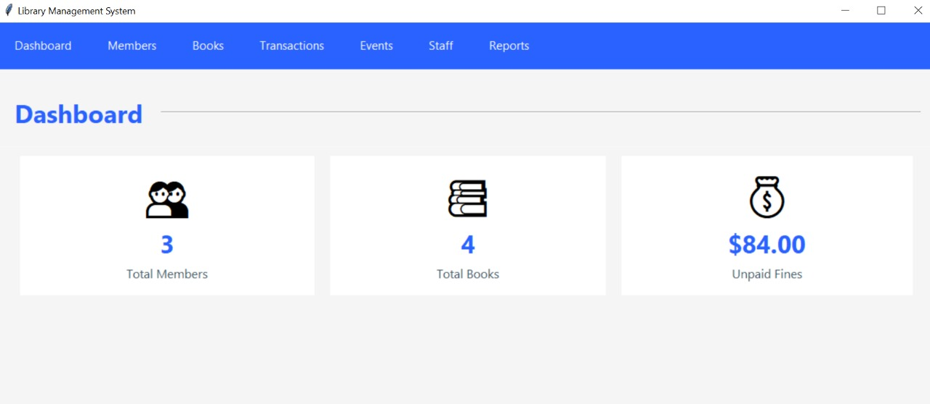

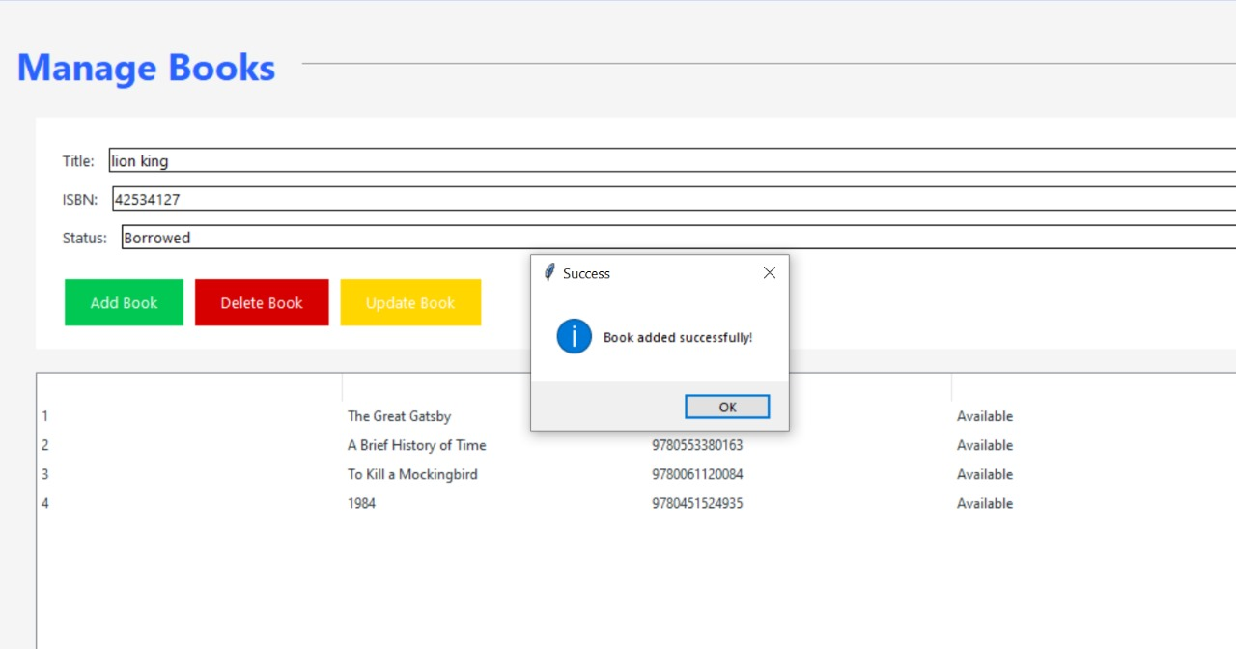

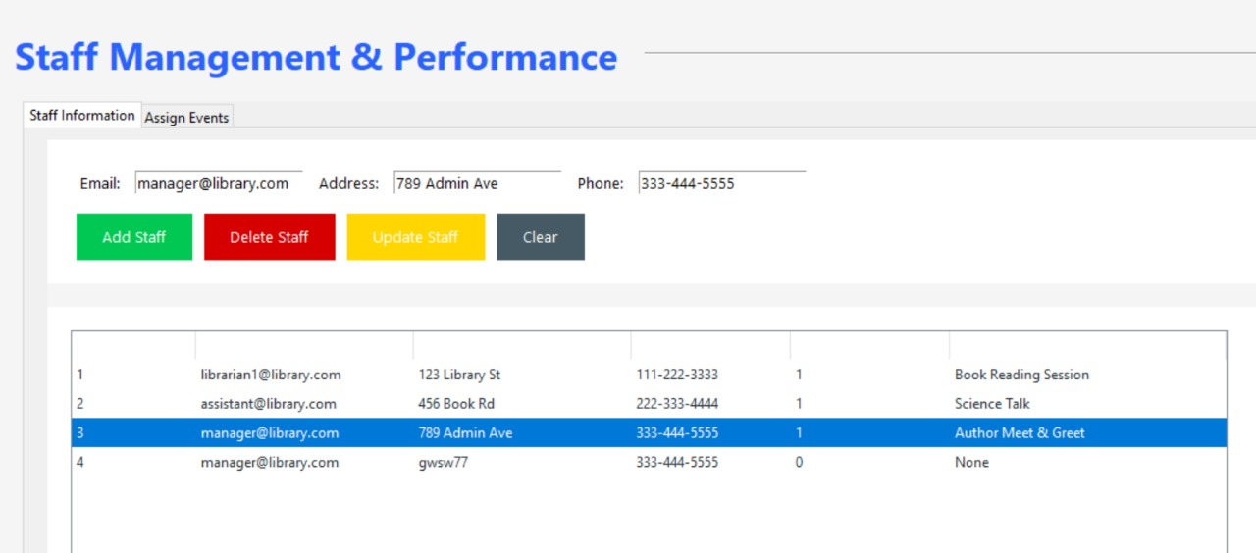

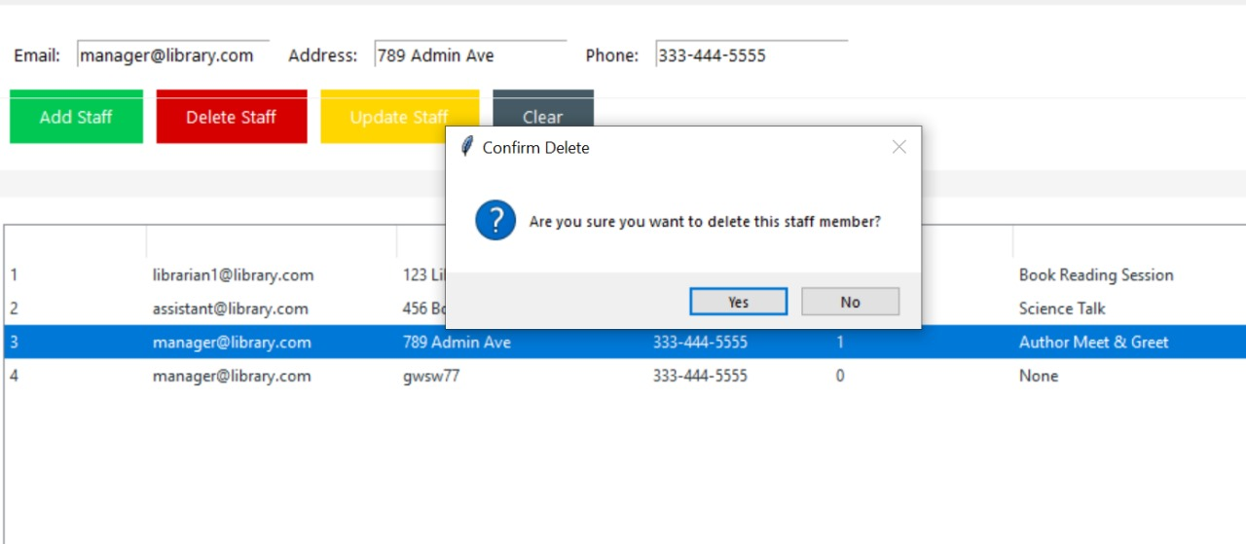

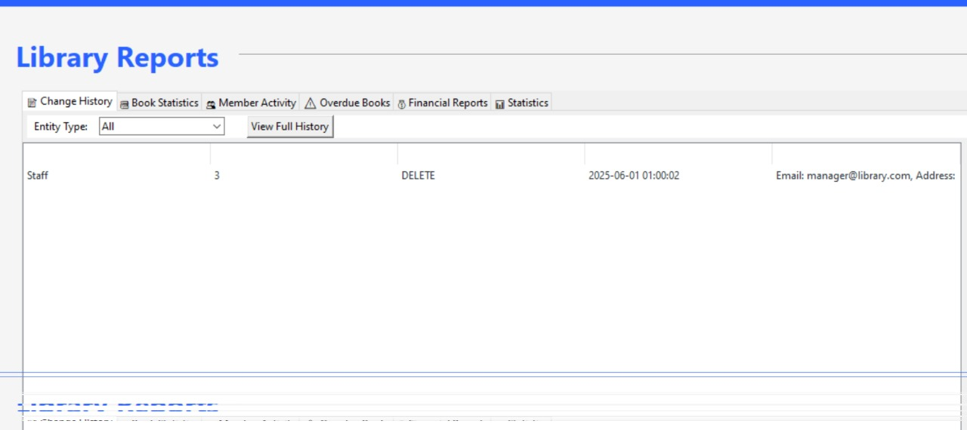

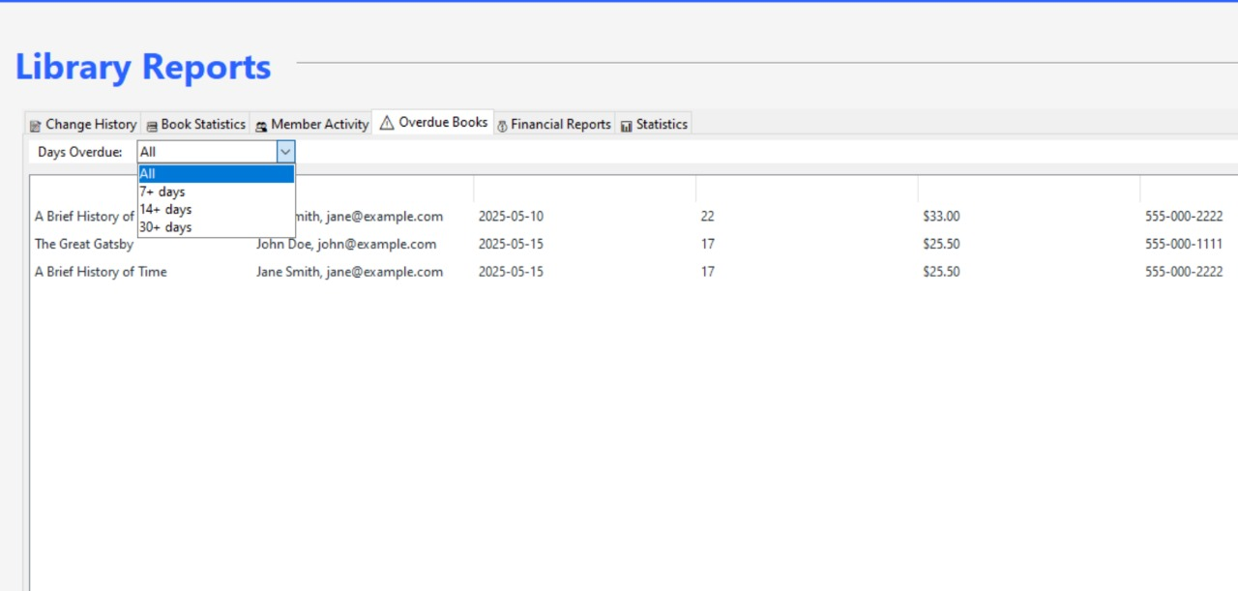

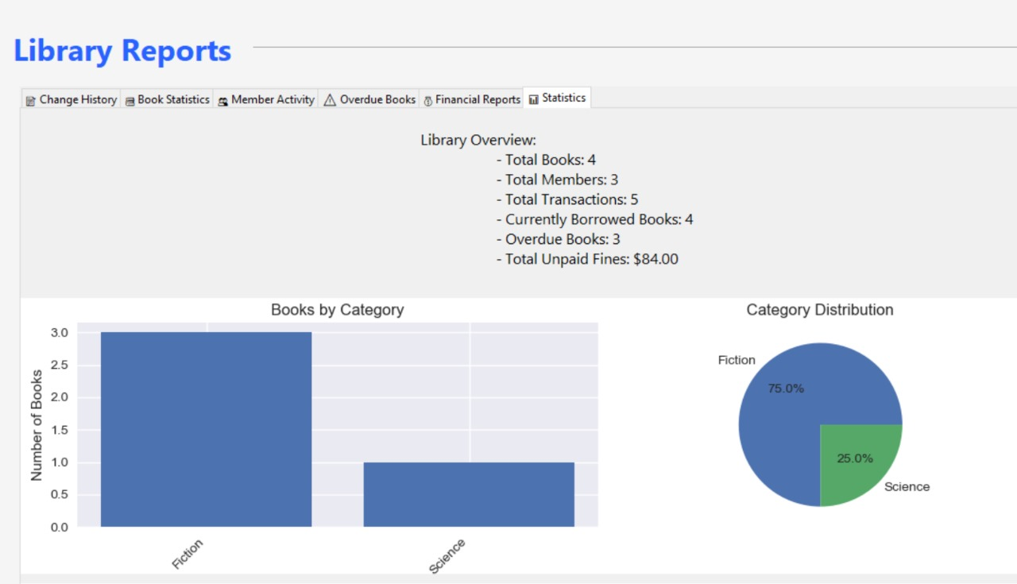

**10.ERD**

**11.Relational Model**

**12. Schema**

